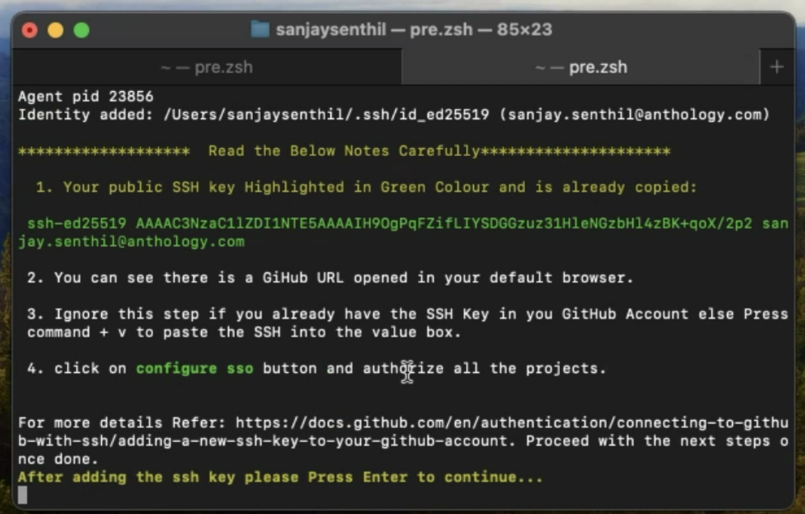

SSH Key is already copied for you , You can see the below screen is opened in your default browser .

1. On the key input text press “command + v”
2. On the title input text give any unique name .
3. Click on Add SSH Key

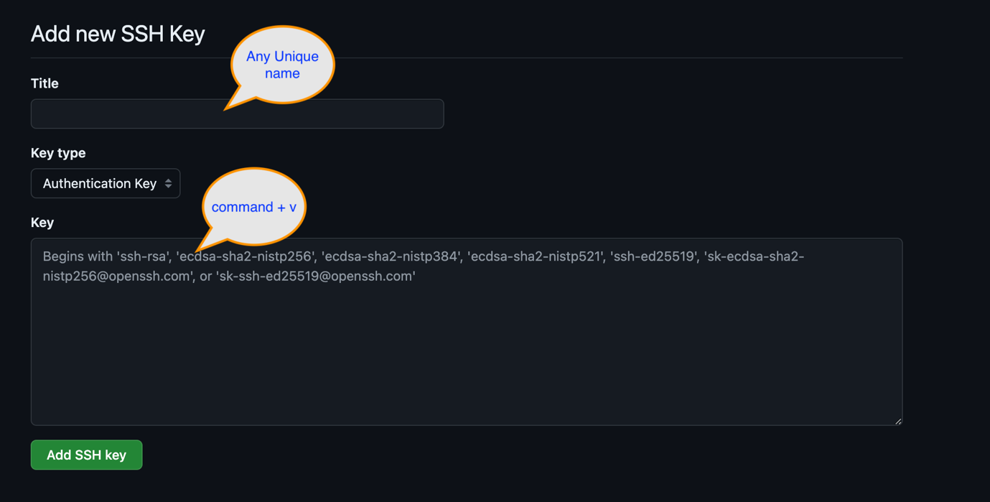

After adding SSH Key you can see a Configure SSO DropDown if not go to <https://github.com/settings/keys> then You should be able to see it .

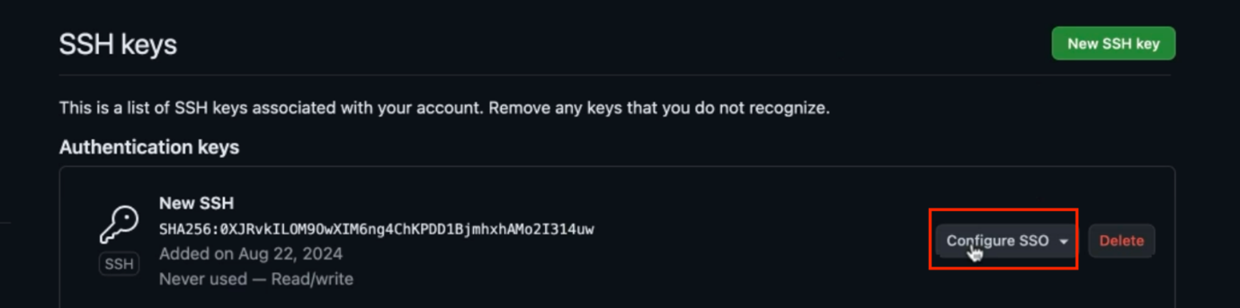

Click on Authorize

